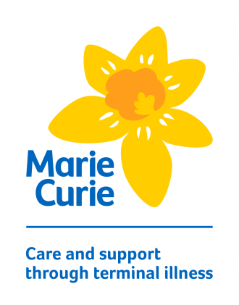
Gambling Self-Exclusion Form

Please complete and sign this form and return it to Marie Curie:

- by email: goodwaystowin@mariecurie.org.uk, OR
- by post: Supporter Relations Team, Marie Curie, 14 Links Place, Edinburgh EH6 9AB

I request to be excluded from all Marie Curie Weekly Lottery, raffle and prize draw activity, including our website, www.goodwaystowin.com, with immediate effect. I understand that by submitting this form, the exclusion will remain in place until I telephone Marie Curie on 0800 716 146 to tell you that I wish to begin gambling again.

Please note that by law the self-exclusion must apply for a minimum period of 6 months.

Title
First name
Last name
Date of Birth
Address line 1
Address line 2
Address line 3
Town
Postcode
Supporter Number
(if known)

Signature: ________________________ Date: ________________________

Getting help
In addition to requesting self-exclusion from all Marie Curie Weekly Lottery, raffle and prize draw activity, including our website www.goodwaystowin.com, there is also software that blocks access to all online gambling sites. Please refer to an online search engine to find these.
For friendly and helpful advice from specially trained counsellors, call the GamCare helpline on 0845 6000 133. It’s open between 8am and midnight, seven days a week, 365 days a year. Outside hours calls are taken by a message service. You can also visit the GamCare website at www.gamcare.org.uk.

For more information on Marie Curie’s approach to Responsible Gambling, please visit www.goodwaystowin.com/responsiblegambling.

